Welcome to our exclusive handmade product selling website, where we curate a collection of meticulously crafted items for those who appreciate the artistry of handmade creations. Our platform offers a seamless and user-friendly experience, allowing you to explore and purchase a diverse range of unique products from the comfort of your home. Whether you are searching for exquisite handmade jewelry, distinctive home decor, or other artisanal treasures, our website provides a curated selection to suit your taste. With the convenience of online ordering, you can effortlessly choose your desired products and place an order with just a few clicks. Additionally, our order tracking feature ensures that you stay informed about the status and location of your purchases in real-time. Our website also boasts a robust search functionality, enabling users to easily find specific products using relevant keywords. Embrace the beauty of handmade craftsmanship with our platform, where every purchase is a celebration of art and individuality.

Craft Page:

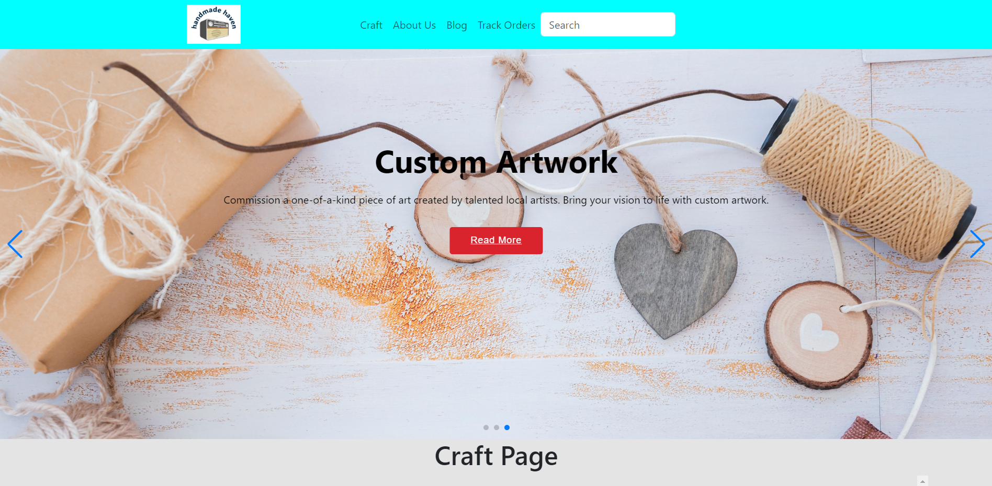

Products:

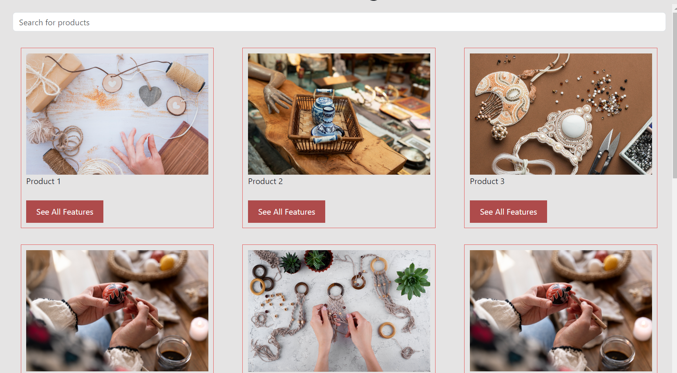

Track-Order Page:

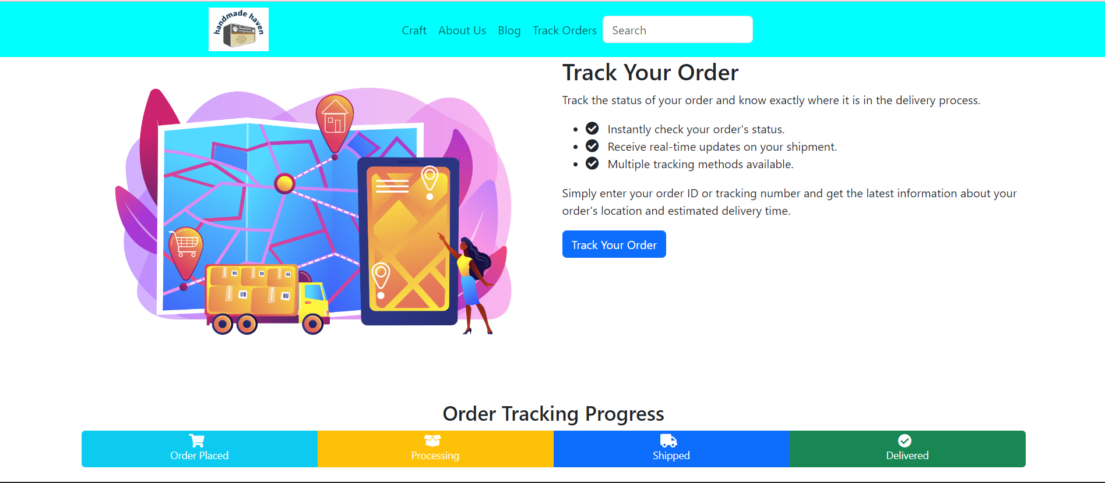

Blog Page:

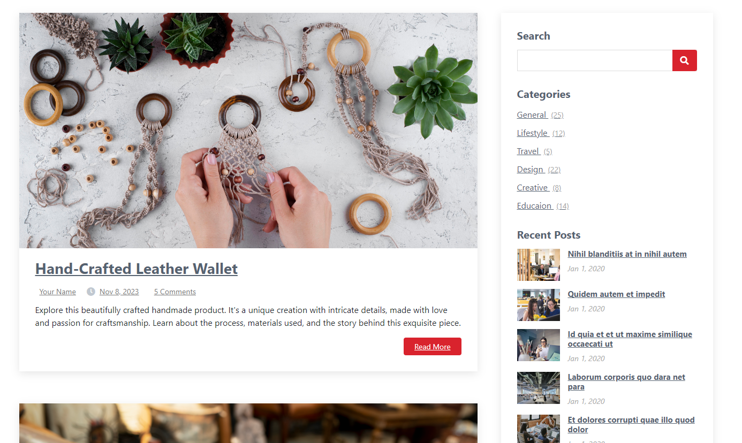

**1. Evaluation of Web Technologies, Tools, and Platforms**

In the development of our web application, we have employed a combination of versatile web technologies, tools, and platforms to ensure a robust and user-friendly experience.

1.1 HTML, CSS, and JavaScript

We have utilized the foundational trio of HTML, CSS, and JavaScript to structure, style, and add dynamic functionalities to our web pages. This choice is grounded in the industry's best practices, providing a solid basis for creating interactive and visually appealing user interfaces.

1.2 Bootstrap Framework

To expedite the development process and maintain responsiveness across various devices, we incorporated the Bootstrap framework. Its grid system and pre-designed components facilitate a consistent and mobile-friendly layout, aligning with contemporary web development standards.

1.3 jQuery

The inclusion of jQuery enhances the functionality of our web application by simplifying DOM manipulation and event handling. This lightweight JavaScript library contributes to the efficiency and fluidity of user interactions.

1.4 Font Libraries

Our commitment to a visually engaging design extends to the integration of font libraries. The use of Font Awesome and other font libraries ensures the availability of a diverse set of icons and typography styles, contributing to a polished and professional aesthetic.

1.5 Swiper for Image Carousels

For seamless and visually appealing image carousels, we've implemented Swiper, a modern touch slider. This choice is aligned with the current trend of providing users with a smooth and interactive browsing experience.

**2. Application of Relevant Tools and Techniques**

2.1 Design and Development

Throughout the design and development phases, we have applied industry-standard tools and techniques. The use of HTML/CSS preprocessors, version control systems (e.g., Git), and code editors with integrated development environments (IDEs) has enhanced collaboration and code maintainability.

2.2 Responsive Design

Our commitment to user experience is evident in our adoption of responsive design principles. Through media queries and Bootstrap's responsive utilities, our web application seamlessly adapts to various screen sizes, ensuring accessibility across devices.

**3. Evaluation According to Industry Standards**

3.1 Development Standards

Our web application adheres to established coding standards and practices. This includes consistent indentation, meaningful variable naming, and modularized code for improved readability and maintainability.

3.2 Usability and Accessibility

Usability and accessibility are paramount in our project. We've conducted thorough testing to ensure a user-friendly interface and have adhered to accessibility guidelines (WCAG) to guarantee inclusivity for all users, including those with disabilities.

In conclusion, our approach to web development integrates a thoughtful selection of technologies, tools, and platforms, aligning with industry standards and best practices to deliver a high-quality and accessible web application.